Ex.No:8: POWER SPECTRAL DENSITY (PSD) ANALYSIS OF PHASE MODULATED (PM) SIGNALS USING MATLAB
Objective 1:
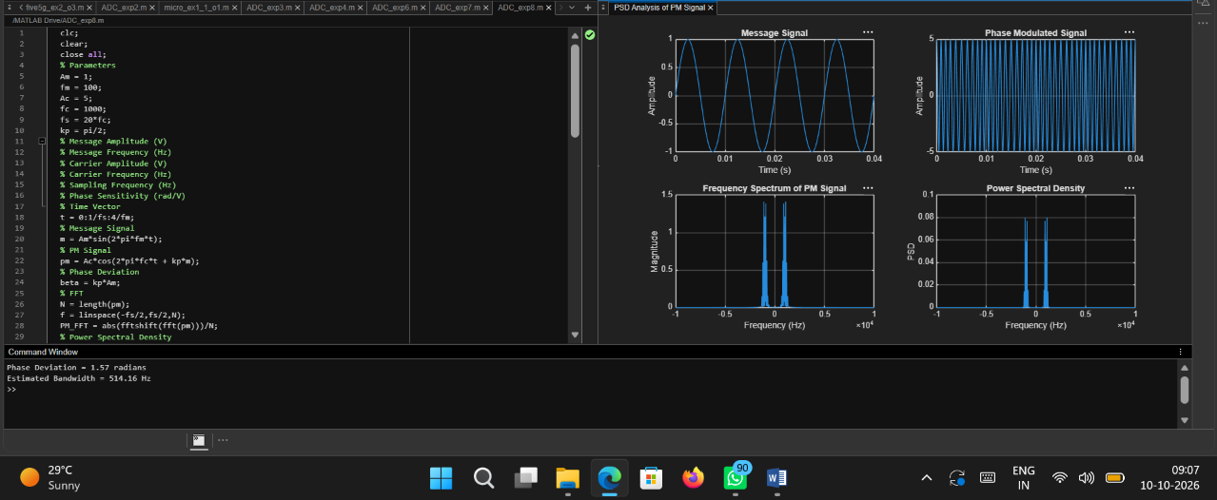
Code:
clc;
clear;
close all;
% Parameters
Am = 1;
fm = 100;
Ac = 5;
fc = 1000;
fs = 20*fc;
kp = pi/2;
% Message Amplitude (V)
% Message Frequency (Hz)
% Carrier Amplitude (V)
% Carrier Frequency (Hz)
% Sampling Frequency (Hz)
% Phase Sensitivity (rad/V)
% Time Vector
t = 0:1/fs:4/fm;
% Message Signal
m = Am*sin(2*pi*fm*t);
% PM Signal
pm = Ac*cos(2*pi*fc*t + kp*m);
% Phase Deviation
beta = kp*Am;
% FFT
N = length(pm);
f = linspace(-fs/2,fs/2,N);
PM_FFT = abs(fftshift(fft(pm)))/N;
% Power Spectral Density
PSD = (abs(fftshift(fft(pm))).^2)/(N*fs);
% Approximate Bandwidth
BW = 2*(beta+1)*fm;
fprintf('Phase Deviation = %.2f radians\n',beta);
fprintf('Estimated Bandwidth = %.2f Hz\n',BW);
% Plotting
figure('Name','PSD Analysis of PM Signal','NumberTitle','off');
subplot(2,2,1);
plot(t,m);
title('Message Signal');
xlabel('Time (s)');
ylabel('Amplitude');
grid on;
subplot(2,2,2);
plot(t,pm);
title('Phase Modulated Signal');
xlabel('Time (s)');
ylabel('Amplitude');
grid on;
subplot(2,2,3);
plot(f,PM_FFT);
title('Frequency Spectrum of PM Signal');
xlabel('Frequency (Hz)');
ylabel('Magnitude');
grid on;
subplot(2,2,4);
plot(f,PSD);
title('Power Spectral Density');
xlabel('Frequency (Hz)');
ylabel('PSD');
grid on;
Output:
